**Step1)**

**Azure Variables settings for the environments**

Azure provides a way to set variables in .config file during the release of the application. In order to do that, We can edit the pipeline as shown below:

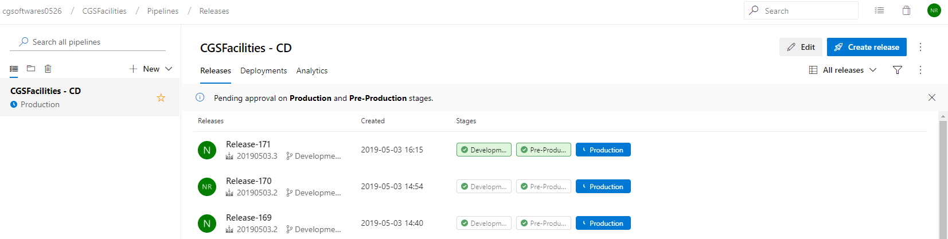

After clicking on Edit on the top right corner, we get to the below screen where we need to click the Variables tab. We here can put the variables to be replaced in the web.config files during the release of the environments.

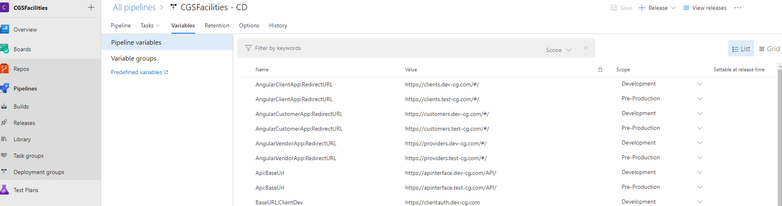

**Step2)**

**Enabling the variable substitution option**

For Azure to be enable to replace the variables defined for the releases, we need to enable the respective settings in release pipilines. We need to click the pipeline as shown below:

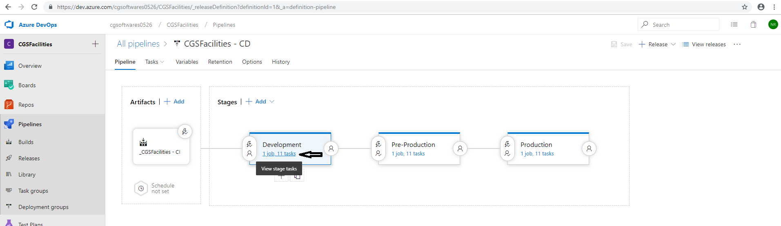

After clicking the job and tasks link, we get to below screen where we click on the individual agents and enable the setting for variable substitution.

